17/10/2024
Mursal, Ahmed
NApier University Student ID: 40646515
Advanced Web technologies
Website Specification Report

Contents
Introduction. 2
Scope 2
Ideas and propositions. 2
The Chosen one. 2
The process 3
Page Navigation. 3
Navigation tree 3
Past Research and experience. 4
Features. 5
Colour palette. 6
User Interface. 7
Implementation. 8
References. 12

Introduction.

Scope
This report is about coming up with a problem and solution to further my experience as a software engineer given a specific time frame am meant to come up with an idea for a website and create it using HTML, CSS, JAVASCRIPT and a library In python (flask) bonus points If I use APIs there is no word count for this report since the more detailed the better, strap in and enjoy your reading.

Ideas and propositions.
this section will talk about possible ideas.
- Real time chat application
- Weather application
- To do list
- Baked goods sale page
- Personal portfolio
- Note taking app.
- Event planer calendar with weather prediction, task management with a priority status.
- Recipe finder
- Bulletin board
- Quiz and flash cards app.
- Chat simulation game.
- Multiple mini games app

The Chosen one.
I decided to work on number 7 and my reasoning is the more complicated the project is, the more I will gain in the long term and it seems doable considering my current skill level and past project experience, I will be using visual studio code to create this project and the ultimate goal is a web app with a splash screen and a customisable home page that resets on reload just so that I don’t have to store the preferences of the user In local storage or the database, a fully functional calendar with an even planner, a page completely dedicated to creating a to do list and specifying the priority of each item along-side when its due, a weather prediction page which will rely on APIs to grab the data and display it to the user, if the time limit allows it I will attempt to integrate the weather prediction feature with the calendar and event planner for the sake of convenience for the user.

The process
I will start by adding in all the useful plugins visual studio code offers such as live server and prettier, and SQLite, then I will create a directory for the project and allocate it the necessary sub folders, then create the logo and icon alongside researching other similar sites and mini projects examples from code pen to help with generating ideas and to come up with a manageable outlay as well as add some colour changing features to the app to make the users feel better about customising it, I will then add a splash screen that goes away after a few seconds of the user moving their mouse and that will be the total of 4 pages, one for the splash screen the others for the home page, To-Do page and weather page. The home page will be the one that holds the calendar, the Todo page will hold events and tasks and allocate a priority list alongside a complete and in progress list such as the GitHub projects list and the weather page will display past and future weather predictions.

Page Navigation.
The home page will include a navigation bar granting the user the ability to comfortably move through pages.
- Splash Screen
- Home Page which will have the calendar inside it alongside page customisation which resets when the page is refreshed.
- To-do page
- Weather page. This page should be customisable as well and it should display past weather forecast along with upcoming weather forecast predictions (if there is enough time, I can make it inform the user of the specific weather prediction based on their events)

Navigation tree
Below is a picture made on mock flow describing how my website will be arranged the idea is that the splash screen will only take the user to the home page there will be no sign-up page or user authentication these will be features implemented later on if there is enough time, as for now it’s just a basic web application, once the user is at the home page they can then choose to add an event, customise the page or move on to the Todo page, where they can add or remove tasks, set their priority level and set their level of progress from not started, in progress to complete, for my fellow procreators I plan to add another section In the future called start tomorrow I still have plenty of time, and lastly there will be the weather page where users can see the weather predictions.

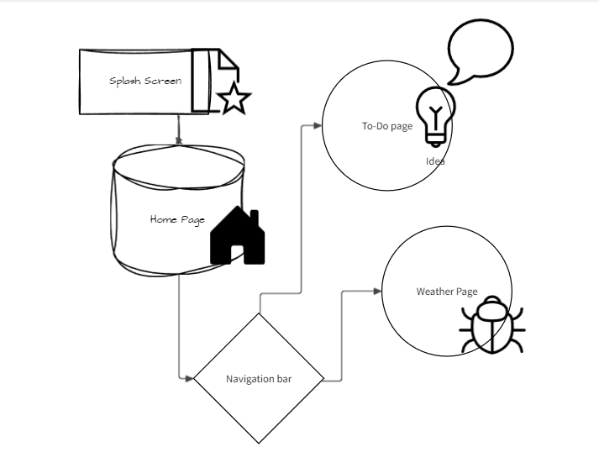

Past Research and experience.
In college I had built my first website for a dinner, and it was mostly front end only outstanding feature it had was saving the bookings data to local storage, but it taught me how to use HTML, CSS, and Java Script to an extent.
After that I signed up for a personal plan in Udemy and I have completed a few courses to help improve my skills and understanding, along with watching YouTube tutorials and looking at CodePen’s projects for inspiration and using the code viewer feature to better understand how some parts were developed or created.
I am currently in the process of completing a crash course on Udemy which will teach me how to use flask and APIs as well as how to deploy websites.
Aside from these courses, there is also a very thorough workbook provided by my current professor which also teaches me how to do all this step by step I will attempt to complete its walk through to the best of my ability.

Features.
Below I will include a list of features in the form of bullet points then I will elaborate onto them further.
- Splash Screen.
This feature is included in to make the website seem more interactive and interesting.
- Customisable screen
To make the readability easier for the user and to match different users different preferences
- Weather Predictions
Everyone hates when they plan something and relying on luck to have good during the days of said event it just seems convenient to know what the weather will be like to have a more enjoyable time and a successful experience.
- Event planner with calendar
The calendar is used to show what the current day is and what other planned events may include on other days as well as to remind the user of their upcoming events.
- Page navigation
Simplifies the website and makes it less cluttered way better than having all the functionalities in one page, it would simply be too distracting for the users.
- To Do list
To remind the users of their tasks and the progress rates of said tasks.
- Save, delete, and alter database.
It stores and alters the input of the user making the website slightly more interactive and intuitive as well as allows the user to see their past actions, planned events or tasks.

Colour palette.
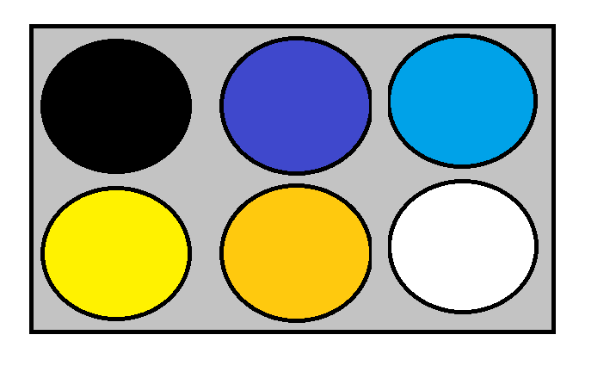
The colour palette is not permanent though and that is because the user can alter them as they like, and it will all be preset once the page is reloaded.

User Interface.
Below is a picture of what the interface will look like and what its current capability is, as you can see the calendar has the current date highlighted and the user has the ability to navigate between the previous and next months to add events, aside from that the user can also customize the pages colour to match their preference, and if the user decides to click on the logo it will take them back to the splash screen where they can leave at any time by simply moving the mouse, the user has the ability to change the colour of the background, text, navigation bar and finally the text on the navigation bar these colour changing features are available for all pages except the splash screen.
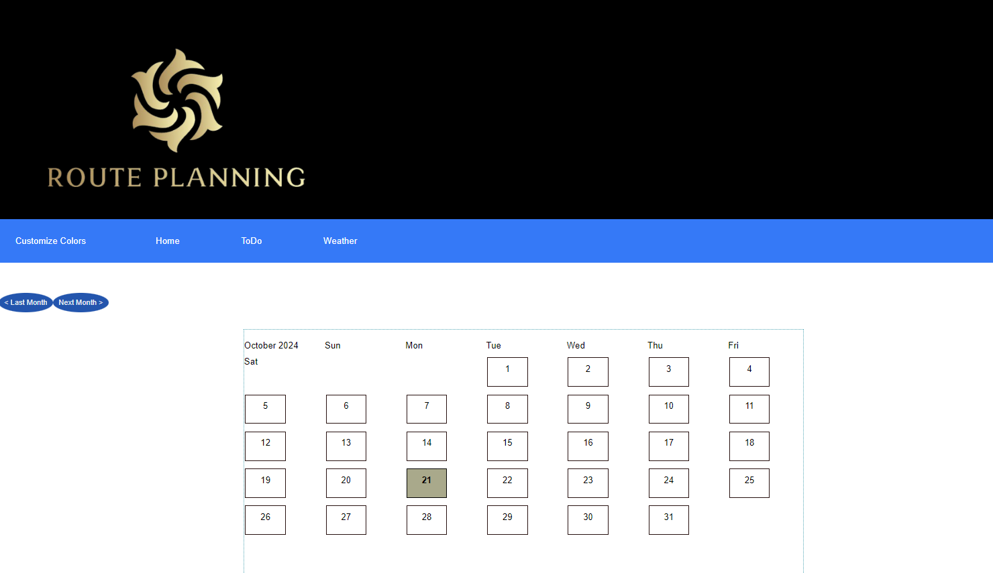
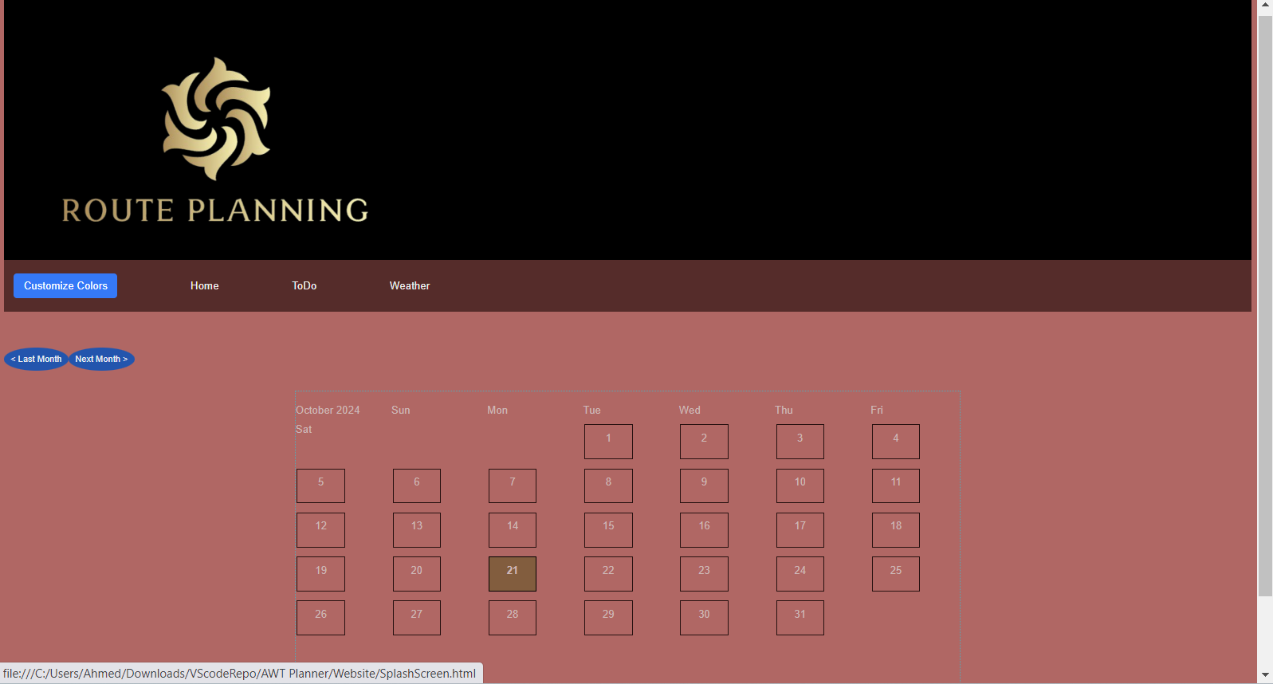

Implementation.
Implementation plan includes.
- Gathering intel
Gathering intel by viewing suggestions and viewing past similar projects alongside creating mock ups on mock flow and wire frames to grasp a better understanding of what am creating as well as writing this report and gathering information about what APIs I will be using, how to implement the database and what framework I would use along side the database structure itself.
- Setting up the development environment
I will be using visual studio code because of its flexibility and abundant useful plugins and features; which includes live server which allows me to view changes I made in real time without refreshing the page but I need to save the changes before being able to see them, prettier which will rearrange by html and CSS making it more readable and clears out any unnecessary items, SQLITE which would allow me to access the data in my tables without having to constantly write statements to view it just makes the thought process easier, I will also be creating the projects directory which will include other directories or subdirectories such as the project documentation and the websites directory itself.
Before starting on the project I will create prototypes of different features to make sure that am capable of making what I want then I will integrate them together, I will start by making the page navigation, adding the logos, and splash screen, then I will add the calendar and its events, after successfully integrating the calendar and the database to store the events I will work on creating the Todo page and lastly will be the weather page, if the time frame allows it I plan to integrate all of these features together to make a calendar that has information of all upcoming tasks and events, their priority level, level of completion and the weather.
- Version control
I will create a GitHub repository to store my changes, track my progress and allow me to be able to revert back in case I mess up.
- Database Design and set up.
Below is an image of the structure of the data base, I start by naming the database and giving it the .db extension after doing so I created the make database file which is only a file which contains the instructions on how a database can be made out of a few SQL lines and python, I start by creating the connection to the database then confirming it then I create the tables only if they don’t exist already and inside the tables I define the columns allocating their required values such as Integer, String or Date, next up would be defining the foreign keys which would be used to link the tables to allow me to be able to show, delete and alter information on both tables with ease instead of creating a few statements to do the same thing over and over and this is achieved by the on delete cascade on update cascade SQL function.
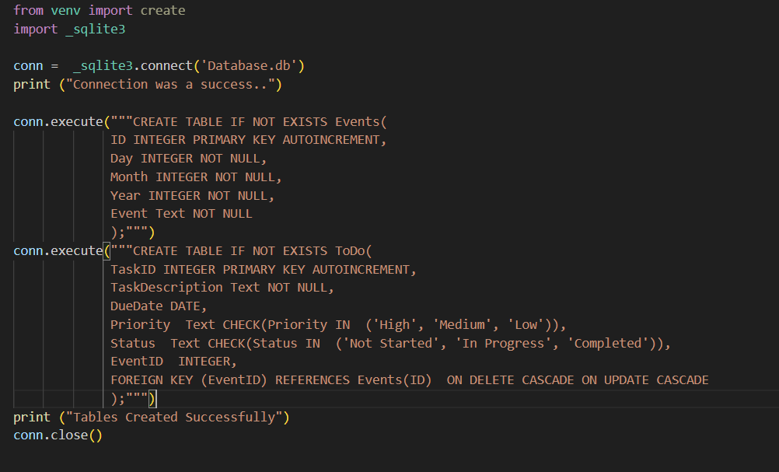

- Deployment plan.
There are several types of deployment plans which include:
Custom Deployment Plan: A tailored plan for a specific project or product, considering unique requirements, resources, and timelines. This plan outlines tasks, dependencies, and risk management strategies to ensure a successful deployment.
Key elements:
Project Specific requirements: the plan takes into consideration the specific goals, technical constraints, and compliance requirements of the project.
Tasks Breakdown: clearly defines all tasks required for deployment from pre-deployment set up to post- deployment Support however that will not be considered much because the projects development will not go any further after achieving the current goals.
Dependencies: identifies the dependencies between various components, ensuring smooth and precise integration during deployment.
Phases of a custom Deployment plan:
Planning Phase:
This involves detailed analysis of the project, identifying specific needs and constraints then tailoring the deployment plan accordingly.
Testing Phase:
This phase ensures that all components of the system are thoroughly evaluated in a controlled environment to identify and potential issues before they go live or onto the next phase.

Pre-Deployment Phase/ Implementation Phase:
This phase includes all the ground work being laid out meaning all previous phases completed successfully and identifying the potential risks that come with migrating the application as well as any other constraint that could possibly hinder the deployment or development of said project, this phase also includes creating the back up and contingency plan ensuing that roll backs are possible at any moment an error occurs,
Then the application is deployed and monitored in real time to evaluate all of its capabilities and ensure that its actually functioning as it was intended to.
Post-Deployment Phase:
After deployment there should be provisions for ongoing support to resolve and issues and ensure optimal system functionality, but this does not apply to this project.
Best Practices for this type of deployment plan:
Flexible design: the plan should allow for some flexibility in case of unforeseen issues arising.
Documentation: all customizations and decisions should be well documented for future references or potential rollbacks especially now that am using version control.
- API (Application Programming Interface) integration and Data Flow.
- API integration and Data Flow are crucial aspects of connecting different systems and enabling seamless, smooth communication and data exchange between them.
- Client Side:
- The client-side initiates or starts the transaction of the data flow by sending a request to the API this can be performed through the front-end interface be it web app, mobile app, website, or a back-end system.
- The request contains the parameters, headers or payload which are often in the forms of data or JSON objects.
- API Gateway:
- The request then passes through an API Gateway or middleware that manages the traffic, manages the routing, and performs security checks like authentication and verifications.
- The gateway ensures that the requests reach the correct API endpoint while applying any necessary changes in formatting.
- Server/Backend:
- Once the API receives the request, the backend system processes it and this might involve querying a database in this case r performing calculations, fetching data from other APIs or services which might be used in the weather prediction section of the website.
- The server prepares the response wither it be data or acknowledgment of actions taken then it sends it back to the client using the API.
- Response Flow:
- After receiving the response to the client either directly or using the API gateway the response can contain the request’s data it can be the user’s info or product details or a status message the success or failure of a process anyway after receiving it the client processes and displays thee data or takes further action to decrypt it based on the APIs response.
- Data Transformation:
- During the data flow transformation might be necessary to convert the data between different formats such as JSON or XML ensuring compatibility between systems mentioned before as the API taking further action in number 8.
- Real-Time Data Flow:
- In some cases, the real-time data flow is required in live tracking or Streaming services this can be achieved using web sockets or long-polling in APIS where a continuous connection is maintained between the client and server side for instant data updates difference between them is one allows the client and server to make requests or sent information at any time while the other doesn’t.
- APIs I will be implementing.
https://www.weatherapi.com/
I don’t have much to add regarding this section because I haven’t started in building it yet and learning by practice is my method of understanding, above this I mentioned the theory behind the communication between the client and server side and I discussed how an API is basically a third-party that relays the data in different formats allowing for a continuous or non-continuous communication and transaction between services or objects in the web-app or website.
By doing this further research I realised that I could have used a google calendar which includes a Todo list function it seems… I do not know how to feel but I will link below the resources.
- Coding libraries
Flask:

- Offers reusable code for common web development tasks, such as routing, templating, and request/response handling.
I will be relying on the flask feature rendering templates of my html, CSS and Java script files the only thing which I consider a problem right now is that am not too experience with flask so I cant write the report in depth as I had wanted to but it’s a planning report so instead I will discuss what I plan to do next and the methods which I might think are appropriate to use.
- Extensibility: Support for third-party libraries and extensions to add features like database support, authentication, and more
Am not currently sure If I want to implement a login screen with a user authentication to display specific instances from the database and display different calendars and Todo lists to different users I like the idea of going to a login page after the splash screen but am not sure if the time frame would allow me to add such a feature.

- Testing plan
My testing plan will include functionality testing, unit tests along with UI tests to ensure seamless cooperation between pages and buttons, navigation as well as ensure basic functionality all the files detailing these tests will be included in the project documentation folder.

References.
Past Projects.
Codepen.io. (2017). Event calendar. [online] Available at: https://codepen.io/usamahamed/pen/ZvbGBg.
pythonbasics.org. (n.d.). Flask SQLite database - Python Tutorial. [online] Available at: https://pythonbasics.org/flask-sqlite/.
www.javatpoint.com. (n.d.). Flask SQLite - Java point. [online] Available at: https://www.javatpoint.com/flask-sqlite.
Udemy. (2024). Online Courses - Learn Anything, On Your Schedule | Udemy. [online] Available at: https://www.udemy.com/course/python-and-flask-bootcamp-create-websites-using-flask/learn/lecture/10533496#overview.
Polling, L. (2020). Short Polling vs Long Polling vs Web Sockets - System Design. [online] YouTube. Available at: https://youtu.be/ZBM28ZPlin8
www.youtube.com. (n.d.). What is an API (in 5 minutes). [online] Available at: https://youtu.be/ByGJQzlzxQg
in (2023). APIs Explained (in 4 Minutes). [online] YouTube. Available at: https://youtu.be/bxuYDT-BWaI
Web technologies: server side, by Simon Wells.
The flask project book, by Simon Wells.
Bishop, K. (2024). A Step-by-Step Guide to Creating a Deployment Plan. [online] www.fool.com. Available at: https://www.fool.com/the-ascent/small-business/project-management/deployment-plan/
Kumawat, A. (2023). What is an API (Application Programming Interface)? [online] GeeksforGeeks. Available at: https://www.geeksforgeeks.org/what-is-an-api/
Rahman, H. (2024). Long Polling vs WebSocket: Key Differences You Should Know. [online] Api dog Blog. Available at: https://apidog.com/blog/long-polling-vs-websocket/
Google (n.d.). Google Calendar API Overview. [online] Google Developers. Available at: https://developers.google.com/calendar/api/guides/overview.
Google for Developers. (2024). Google Tasks | Google for Developers. [online] Available at: https://developers.google.com/tasks/
Weatherapi.com. (2021). Free Weather API - WeatherAPI.com. [online] Available at: https://www.weatherapi.com/.

‌

‌

